Central Asia CSO Partnership for Development Effectiveness (CPDE)
Sub-Regional Meeting
3- 5 December 2012
Dushanbe, Tajikistan

- BACKGROUND and RATIONAL

The civil society organisation (CSO) Partnership for Development Effectiveness (CPDE) is an open platform that unites CSOs from around the world. It is open to the participation of any CSO that promotes human rights, participatory democracy, social and environmental justice, equality and decent work. CSO plays critical role in the economic and social development of the society and CPDE will support CSO from around the world to strengthen diversity and pluralism of social discussions and policy through bringing to responsibility governments and donor organizations as well by promoting advocacy for human rights, fundamental freedom, equitable democracy, sustainable development and proper governance.

CPDE is the brainchild of two platforms Better Aid and Open Forum engaged to the aid effectiveness agenda for several years. The rows of meetings, consultations and discussions that are have been prefaced to the nascency of CPDE. A lot of CSO have made their contributions and inputs to the development of the platform.
There are 4 outcomes is set up by CPDE to be implement on the contry level, subregional and regional levels such as expunding representative coverag and recognisions, implementation of Istambul Principles and International Framework, engaging with all key stakeholders, at all levels and realyse CSO asks related to Busan. With the purpose to impement set up objectives on subregional level sertain structures have to be created and the row of development strateges have to be made.
- OBJECTIVES

Sub regional consultations were focused on the implementation of CPDE on the country level, based on the current agreements of all its members and cover a few countries as an optimal means to support the development of CSO capacities, processes, initiatives around country issues and concerns.

The following indicative plans as deliverables should be reached during consultations such as: 1.Country policy work on overall development effectiveness and development cooperation; 2.CSO development effectiveness country implementation; 3. CSO enabling environment country advocacies; 4.Sub-regional engagement in intergovernmental and sub-regional institutions on issues of development effectiveness of development cooperation and on measures to promote CSO development effectiveness and enabling environment at sub-regional level
Structures of governance and support as well as working groups at sub-regional level have been finalized: 1.confirmation of sub-regional convenor; 2. confirmation or selection of country convenor; 3. confirmation of sub-regional coordinating committee; (agreement on the hosting of sub-regional secretariat/ leadership); and, specific mechanisms to relate to the regional and global structures
Representative of CSO from Kirgizstan, Uzbekistan, Kazakhstan and Tajikistan from different sectors such as women and children, rural, youth, education, labour migrant and environment protection participated on the meeting. They are not necessarily involved to the aid effectiveness agenda, but share visions of CPDE. Each country had to be presented more than by four participants, but due to bad weather conditions, passport problem and other reasons nine potential participants wasn’t able to come. Totally 24 people have participate on the meeting, most of them from Tajikistan. Participants were aimed to discuss development effectiveness engagement and development cooperation and further to develop advocacy strategy and strategy for CSO effective development on the country and sub regional levels. Each one country have been represented al least by one NGO dealing with the issue of gender equality and gender empowerment with the purpose to keep 20% quota of women/feminist organisation. Three day program were comprehensive and intensive and have facilitate participants to discuss, talk and share their insights and own experience. (list of participants is attached)
Welcome remarks by Zuhra Hakimova , Executive Director of NGO Jahon, member of the Global Council, interim sub regional focal person
Civil society organizations (CSOs) make a difference in international development. They provide development services and humanitarian relief, innovate in service delivery, build local capacity and advocate with and for the poor. Acting alone, however, their impact is limited in scope, scale and sustainability. CSOs need to engage in government policy processes more effectively. With increased democratization, reductions in conflict, and advances in information and communication technologies, there is potential for progressive partnerships between CSOs and policymakers in more developing countries. However, CSOs are having a limited impact on policy and practice, and ultimately the lives of poor people. In many countries they act on their own or in opposition to the state, leading to questions about their legitimacy and accountability.
Aid effectiveness process has started since Monterey Consensus in 2002 with purpose to improve policies and development strategies, to increase aid effectiveness. CSOs have been actively involved into discussions of the five principles of Paris Declaration and ADE agenda, thereby started their struggle to expand space for their involvement, to promote their priorities and recognition of CSOs as an equal development partners with their own rights.
Nurgul Janaeva, Forum of Women NGOs of Kirgizstan, member of the Global Council, Asia representative of the sectoral women/feminist group. Presentation “Civil Society and Busan”
Chronology of the events and meeting has been presented. Aid Effectiveness process initiated by Development Assistance Committee of the Organisation for Economic Cooperation and Development (OECD-DAC) through creation of Working Party on Aid Effectiveness (WP-Eff) in Monterey. The last one gave a start to a series of High Level Forums (HLF). The first HLF was held in Rome in 2002 and focused on and harmonisation. In the second HLF held in Paris in 2005 donors and governments took obligations to implement five principles of aid effectiveness. CSO have been invited to discussions as well. Implementation of PD was evaluated in HLF in Accra in 2008 attempt were undertaken to address country ownership building more inclusive partnership , and achieving development result. In Accra didn’t focus properly on tied aid and conditionality. In parallel of HLF CSOs also Have conducted two Global CSO Forum in Seam Reap in 2010 and Istanbul Principles have been adopted and Siem Reap Consensus have been reached and Cebu. Culmination of enormous numbers of consultations and meeting between different developments partners become participation of 300 of CSOs in 4HLF in Bussan in 2011. Nurgul highlighted main paragraphs of the Bussan Partnership agreement and briefed about Better Aid Analysis of BPA, particularly democratic ownership, human rights based approach and gender equality doesn’t properly reflected in Bussan document.
In the end of presentations participants requested to conduct separate training sessions on each one HLF. Participants requested to make clarification on interconnection between aid coordination and aid development effectiveness, as well as to clarify what is conditionality, aid fragmentation, tied and untied aid and etc. Also request was received to develop glossary on ADE agenda to deeper understand the issue. For instance, in Tajikistan, for the Government 15 workshops have been conducted only on PD.
Zuhra Hakimova , Executive Director of NGO Jahon, member of the Global Council, interim sub regional focal person. Presentation “CSO Partnership for Development Effectiveness (CPDE)”.
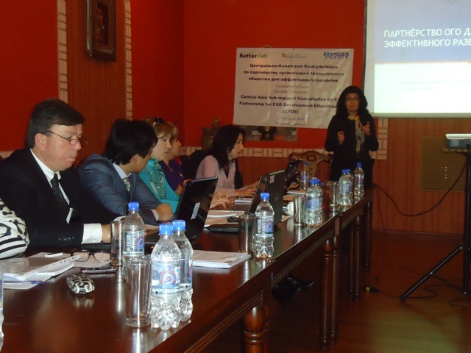
Changing aid architecture, global crises, involvement of new development partners like privet sector, South-South Cooperation and Triangular cooperation, conflicts for recourses and etc pushed CSO to create a unique new platform gathered thousands of CSO all around the world, presenting sectoral and organisational diversity. Creation of CPDE also become a result of restructuring of two CSO platform Open Forum and Better Aid. CPDE is Open Platform and is focused on country level implementation. CPDE set up four targets has to be achieved in 2014 and 2016 and four outcomes. Organisational structure and list of the member of the global Council have been presented to the participant. Result of the Pacific and NEA sub regional meeting have been highlighted.
Participant inquired about any M&E system developed by CSO or for CSO. CIVICUS Enabling environment Index (EEI) were presented. CIVICUS World Allianz for citizen participation, member of CPDE platform has indetified five dimensions for measuring of EEI: the legal and regulatory framework, the political environment, the governance context, the socio-cultural context, and the socio-economic context. Advisory group was created with participation of SIDA, WB, Harvard University and etc. EEI is still under development and after completion of the work will be disseminated among the participants.

Presentation by countries on the issue of aid effectiveness, particularly level of involvement of CSOs in ADE on the country level.
What activity is undertaken by CSO at the moment? Whether government of the country has signed Bussan Agreement or not? If yes, does the CSO or Government develop any ost Bussan action plan or activity?
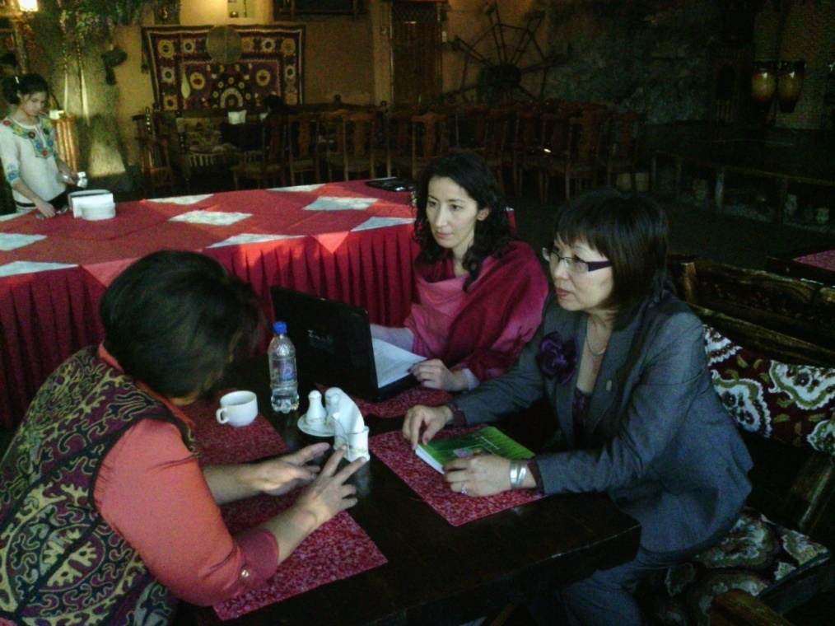
In the end of presentations participants have discussed situations in their country. Each one county has aid coordination mechanism. But unfortunately CSOs haven’t fully involved on it and haven’t considered as an equal development partner. Similar problems have been marked such as: priority of governments haven’t coincide with the priorities of donors, short term projects lead to the aid fragmentation, aid conditionality, creation of duplicate PIUs, provided aid doesn’t use human right based and gender approach , CSO haven’t considered as an equal development partner and haven’t involved to the development of donor’s and government programs. Dependence of donor funds caused unsustainable development.

Similar problems marked in the activity of CSOs, their capacity, actions, and challenges. Participants underlined that activity of CA CSOs are very low. CSOs doesn’t transparent and accountable among themselves. Databank or information on the activity of CSO, amount of grants, sector covered and the effective use of these funds doesn’t exist. Lack of knowledge and low capacity on ADE agenda, ongoing process on the global, regional and sometimes on the national level undertaken by the government and donors as well by CSO. Best practice haven’t used and learned.
But considering existed problems CSO in Central Asia undertake steps and efforts to be involved to the effective development of their countries. Good practice has been presented by Kirgizstan. Created and effectively functioning Public National Councils (PNC) under sectoral Ministries and Committees. Given PNC composed from 10-15 representatives from CSOs. They conduct monitoring and evaluation activity, analysis of the government structures, under which they are created. Criteria for selection for member of PNC are an appropriate experience, good reputation and absence of relative ties with government authorities. CSO take responsibility for their nominated member.
CSO in Kirgizstan can be engaged in to economic activity (for example to have sewing workshop). Incomes received in the result of the activity are used for development of NGO.

In Uzbekistan activity of the most CSOs are controlled by the Government. CSO supported by the means of state budget. Decision on providing of fund to the civil organisation is approved by the Parliament commission, composed from representatives of bank and government. Approval can take up to 9 nine month.

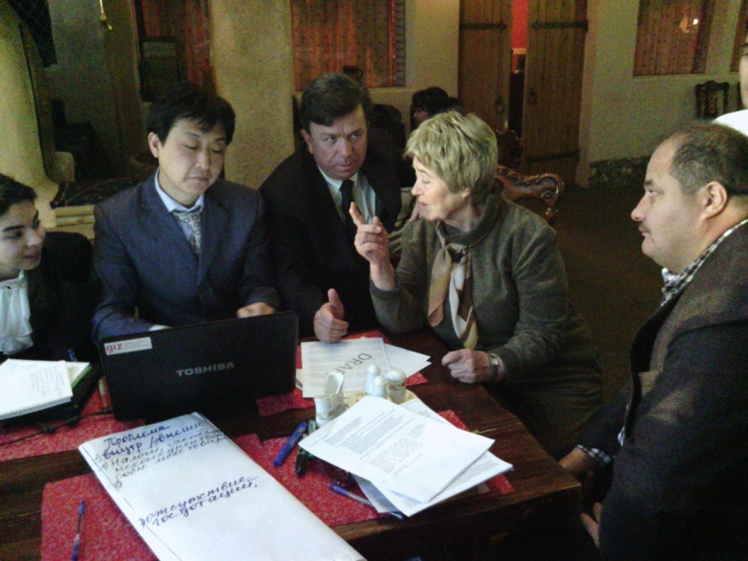
In Tajikistan aid coordination mechanism is lead by the Donor Coordination Council. DCC created on the base of Joint Partnership Development Strategy in collaboration with the Government. Five cluster working group has been created under DCC: 1) development of privet sector, including financial; 2) governance; 3) human development( education, health, social protection), human development (general and cross cutting issues); 4) natural resources (agriculture, land, water recourses);5 ) infrastructure (energy, transport).
Tajik CSOs doesn’t participate in the work of above mentioned group, however negotiation with the government (Committee for Foreign investment) and donors already started. We hope that creation of sub regional Committee will help facilitate the process.
7-8 June in 2010 and 21-22 June in 2011 NGO Jahon have conducted consultative meeting on increasing CSO development effectiveness and their participation in realization of Paris Declaration and Accra Agenda for Action. Consultations have been organized with the support of Asia Pacific Research Network, Open Forum, UN Women and UNCU.
Consultations were aimed to increase awareness of CSO of the importance ADE agenda, and what is the role and impact of CSO on the development processes, their consolidation and interaction with development partners, capability to conduct dialog, to lobby their priorities.
Workshop one. Participants divided by countries on three groups Tajikistan, Uzbekistan and Kirgizstan/Kazakhstan. Due to weather conditions one of the Kazakh representatives was not able to come on time and have arrived only in the end of the first day and made her country presentation in the beginning of the second day. In this connect three group have created. CSO priorities on the country level, challenges (external and internal) CSO can face while implement their activities and promote priorities. What recommendations should be given to CSOs on the actions have to be undertaken on the country level to facilitate and consolidate CSOs, to promote CSO advocacy and engagement. Outputs received can be used when country CSO advocacy and engagement strategy would be developed.
Summary of priorities: CSO capacity building on ADE agenda; involvement of CSO in the beginning stage of the programs, project development; mechanism of cooperation has to be developed; M&E system to monitor and evaluate CSO activity has to be developed, creation of platform for dialog with the development partners; to involve into ADE youth, privet sector, extractive industries.
Summary of challenges: Limited understanding of specific policy processes, institutions and actors; weak strategies for policy engagement; knowledge of language, all papers are on English which is complicated to expand awareness on the activities on the global and regional level, to share best practice and experience; absence of skills to conduct dialog with different partners

Summary of recommendations. to increase understanding of specific policy processes, institutions and actors, strengthen strategies for policy engagement, to increase transparency and accountability among the CSOs, experience and best practice exchange, to conduct awareness campaign for the population on ADE and the role CSOs can play in the process, to use and promote HRBA and gender equality, key documents has to translated on Russian language.

Workshop 2. Result of the discussions – working materials for CSO advocacy and engagement strategy on sub regional level, CSO priorities on sub regional level, indicator for sub regional advocacy and engagement, development of action plane, support from the sub regional level to the country level.
Participants divided on three groups.
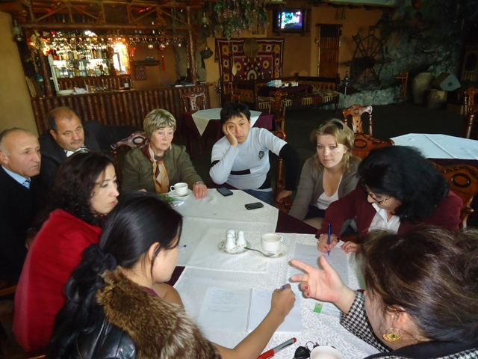
Presentation Group one.
- To develop webpage on ADE on the Jahon website, if fund will be available –to develop portal. To post information by countries, including information on legislation, finance, ADE.
- To increase capacity of CSO to communicate with donor and Government, to attract sectoral experts from Central Asia countries. To compile list of experts
- To the next HLF to prepare appeal with inclusion recommendations from CA sub region
Advocacy
- To create platform for dialog CSO with sub regional donor institutions (WB, ADB) and intergovernmental organizations (Shanghai organisation for Cooperation, European and Asia cooperation)
- To conduct awareness campaign
- To request donor organisation (ADB, WB, EC, UN) to provide country observations and to make comparative analysis of the situation (ADE, policy, socio-economic)
- To conduct Skype conferences
- To develop criteria, indicator for comparatives analysis of the country situations.
Presentation Group 2
А 1. To select sub regional focal person and alternate
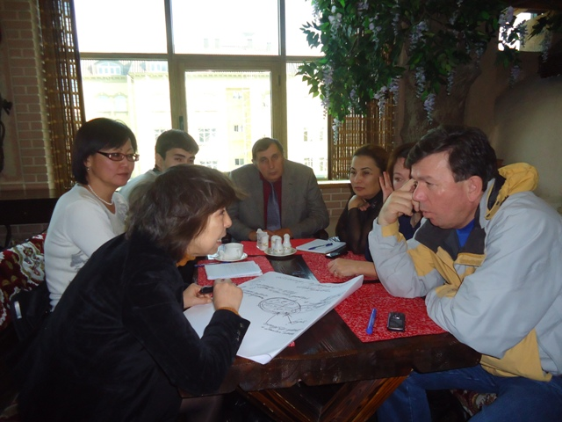
2.To develop methodological basis on sub regional net structure. Разработать методологическую базу по структуре субрегиональной сети (groups and committees)
3. To conduct long-term consultations
4. To conduct multi stakeholders consultations

В
1. To develop and disseminate among donors CA CSO sub regional appeal with our priorities, concerns, including transparency, accountability, use of HRBA and gender equality, use of Russian language
2. To develop and disseminate among CA governments CA CSO sub regional appeal with our priorities, concerns, including transparency, accountability, use of HRBA and gender equality, use of Russian language

- To create CA CSO sub regional structure
- To collect information for the site mentioned before
- To conduct trainings on ADE issues
- To conduct awareness campaign
- To gether group to develop appeal for the governments and donors
- To attract for cooperation on sub regional level Shanghai organisation for Cooperation
- To start to prepare alternates reports along with government and donors report on situations on ADE, policy, economic and etc.

Presentation group 3
Advocacy plus lobby
- To create CA analytical group
- To create group on lobby
- To create group on advocacy
Thematic group
- HR
- Gender equality
- Ecological
- Coordination group

In the result of discussion following recommendations and suggestions were made:

- To expand participation and representativeness diverse group of population, including face based organizations, labor migrants, workers, youth, women and children
- To attract for cooperation ADB, WB, Bank Watch, Veksa
- To share the experience, to use best practice
- To develop indicators of CSO participation in ADE.
- To attract experts from among CSOs to conduct analysis, observation and etc.
- On the stage of project development to reserve some part of funds for ADE activity. It could help to create common pool. At same time to develop projects on aid effectiveness and CSO capacity building
- To use the experience of Kirgiz Public National Councils
- All participants agreed that informational support is required from sub regional level to the country.
- Informational exchange, including progress of activity conducted on the country and sub regional level.
- Intensive discussions went around of database creation on donors program and projects implemented on the sub regional level. Participants agreed to continue discussions on line and decide to what extend database should be detailed, what kind of information it should contain and whom will be responsible for it.

Set up of governance and support structure

- Selection of subregional Coordination Committee
- Selection of Subregional convenor
- Selection of alternate subregional convenor
- Selection of interim country focal person

Taking into account that all processes in Central Asia countries goes slowly, considering oriental mentality and bureaucracy and in many cases authoritarian approach by the Government authorities it was decided select sub regional CC for two years, as an optimal . Rotation principle will be applied upon completion of the term.

In the result of discussions and vote sub-regional coordinating committee, which will serve a two-year term, is composed of the following:
- Sub-regional focal person: Zuhra Hakimova, NGO Jahon (Tajikistan)
- Alternate/co-convener: Farida Abdildaeva, Human Right Center “Citizen against corruption” (Kirgizsatn)
Members of CA sub regional CC:
Tajikistan
- Toginiso Azizova, Public consulting organisation Hukukshinoson (country focal point)
- Dodarbek Saidaliev, NGO Shahrvand
- Ramazan Nurmamadov, Charity Organization Jovid
Kyrgyzstan
- Nuripa Mukanova, Anticorruption business council of Kirgiz Republic (country focal point)
- Bermet Stakeeva, Forum of Women’s NGOs of Kyrgyzstan
- Farida Abdildaeva, Human Right Center “ Citizen against corruption”
Kazakhstan
- Tolganay Ymbetalieva, Public Fund “Central Asian Foundation for Developing Democracy” (country focal point)
- Mayra Abenova, Public Association “Home”
Uzbekistan
- Nargiz Ziyavatdinova, Republican Public Organisation “Women’s Counsil” (country focal point)
- Otaboev Dilshodbek, National Association of Uzbek CSOs
- Tuhtasinova Damira, Center for socio-legal support of women and their families “Kalb Nuri”

Mutually was agreed do not develop very ambitious action plan, considering that most of participants doesn’t aware of ADE agenda and havn’t have understanding of the issue and required additional training and workshop is needed. Participants mostly focused on information sharing, information exchange, awareness and CSO capacity building

- To provide to the all network member full information on the post Bussan CSOs activity at all level – responsible sub regional focal person
- To request WB and ADB to provide reports on the activity of duplicate PIUs supported by these two donor organizations – term 6 month (1 July ) – resp. country focal persons
- To disseminate Russian version of Bussan partnership agreement– document provided to the participants on the flash cards – resp NGO Jahon
- To share website addresses of Reality of Aid, Better Aid, Open Forum, Ibon International among the network members – done – resp. responsible sub regional focal person
- On Jahon website to open ADE page – responsibilities under discussions
- To put on Jahon website glossary on ADE
- To develop and disseminate among CA Governments, donors and Global Council appeal on behalf of CA sub regional CC – resp participants of the consultations
- To conduct CA sub regional meeting at lease on time per year, if fund available (not necessarily support from Better Aid) two times per year.
- Implementation of Istanbul principles

Due to departure of Kirgiz participants it was agreed to continue on-line discussions on the following: functioning of CA CC, TOR for sub regional focal person, alternate focal person, and CA CC

Due to late arrival of Ava Danlog (December 4 p.m) and departure of Kirgiz participants in the morning of the next day (December 5), Ava have been requested to make her presentations within last one and half hour.

Ava Danlog, Coordinator Reality of Aid, Presentation Country level CSO on development effectiveness, Istanbul Principles
In the beginning participants have been requested to ask question they have after one and half day of consultations. Several questions have been asked; 1) Methodology for collecting information, planning methodology and financing; How to push donors to start negotiations with the CSO; How to push governments to sign important agreements and fulfill the commitments; what is the pushing up mechanism for donors and governments to share information; how to set up partnership relation among the development partners.
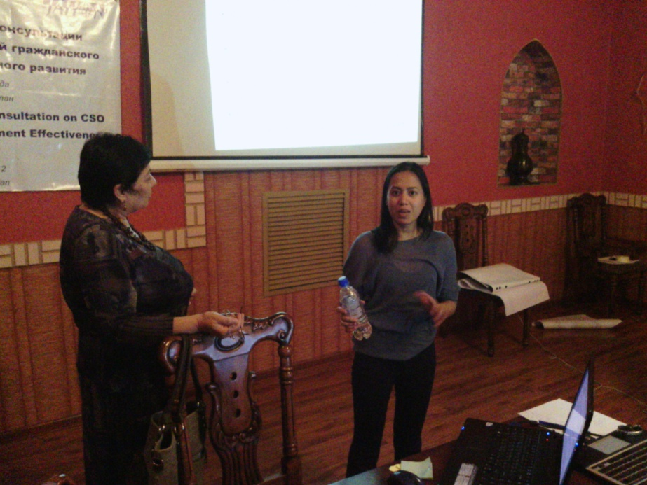
Ava have underlined the roll of CSO in advocacy and engagements
CSOs are able to shape development cooperation policies and practices by taking an active role in partnerships and the development process
Areas for advocacy and engagement:
Development policy formulation- International aid reform agenda emphasizes country leadership in the national development process. Formulation of policies and strategies and coordination of development cooperation should be inclusive to respond to the needs of the poor and marginalized.
CSOs bring into the discussion table the concerns from the grassroots and communities, opening spaces for discourse and opportunities for the meaningful participation in the planning and decision-making process. In the process, ensuring that the national agenda or framework for development will be particularly responsive to the needs of the poor

Development cooperation policy formulation- Development policy of a country will guide long-term partnerships and strategies with donors, intl organizations.
CSOs facilitate positive relations between developing and donor countries and international organizations.
CSOs have strong and trusted partnerships with their networks and counterparts and have established credibility in reflecting the actual state of affairs in countries where they work
Grants and loan contracting-
CSOs have the capacity and experience to leverage on their networks to secure resources. Efforts should remain in line with the national agenda for development and country’s development cooperation policy
Program and project management- In support of government work, CSOs can facilitate the delivery of important goods and services to ensure access for the poor and marginalized. CSOs can also broaden citizen participation and bolster ways of holding governments accountable by monitoring inefficiencies, excesses and corruption with these institutions and raising them to the proper venues to be addressed
Sustainability and institutionalization- CSOs can contribute to the monitoring and evaluation of programs by providing input and reporting observations based on actual experiences on the ground
Multi-stakeholder country results framework- country-led development results frameworks aim to assess performance based on indicators drawn from national development priorities through a systematic inclusive process. The unique role of CSOs as the voice of the poor in these processes ensures that focus is on holistic development
Country donor coordination platforms - Donors should commit to harmonizing on partner countries’ terms, under partner countries’ leadership ad in line with the partner countries’ program and priorities. Processes and platforms for a joint review program exists. CSOs needed to be better integrated in donor coordination efforts to help bridge the gap between donor financing commitment and action at the country level

Parliamentary budget and related audit processes- Budget is a tool to reflect a country’s priorities. As the representative of the people in the government, the parliament is the appropriate place to ensure that the national budget matches the country’s needs with available resources. Busan acknowledges the role of parliamentary oversight mechanisms in implementing greater transparency in public finance management, procurement and audits. The meaningful engagement of CSOs in parliamentary initiatives on budgeting will require access to information as well as support to developing capacity to conduct reviews and other independent accountability and watchdog functions

Istanbul principles, Open Forum and CPDE toolkits have been presented

In the end of presentation participants requested separate training on each one toolkit and to translate them on Russian.

During the last day participants have continued work on the appeal started in the evening of the second day of consultations (Appeal is attached). Accounting presentations made during sub regional planning following groups have been created.

Sectoral Thematic group Working group
Labour migrant Human right analytical
Women and children gender equality lobby group
Farmers ecology facilitation group
Youth anti corruption

Composition of the group and mechanism of interaction with the regional sectoral and thematic group will be discussed on line.
In the end of consultation participants have been asked to fill in evaluation form to appraise the work of facilitators, organizers, methodology and ets. Participants have been provided with the flash card containing translated some of the key documents and presentations made during consultations.

Zuhra Hakimova thanked the participants for intensive and active work, sharing of the experience, for their contribution into development of the appeal, sub regional action plan. As sub regional focal person she promised to fulfill all the commitments taken during the consultations and during two year of the term.
Participants expressed their gratitude to the organizers and sposors of the meeting for the arrangements of this consultation. Consultations were very informative and substantive, big volume of completely new information. Kazakh colleague, for instance, were happy to be involved into the activity as hadn’t heard before, that CSO could be so actively involved to the policy, economic and development issues, that CSO able cooperate with donors and government to influence on the situation in the country, become partner of the government and donors and serve not only as a service provider. Participants expressed their willingness to continue this important work in their countries.
CA participants requested more often to organize such meeting. Due to big volume of information and accounting that most of participants are beginners, it was complicated comprehend and thoroughly investigate the ADE. In this connect training workshops on the ADE issue and toolkits and translation of key documents, toolkits, and major documents on Russian are required.

