Putting People
at the Heart of
South-South Cooperation

An Official BAPA+40 Side Event
21 March 2019 | Buenos Aires, Argentina

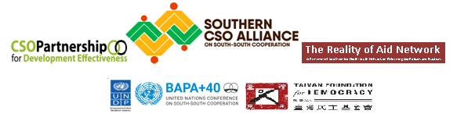
Introduction

Civil society has placed high hopes on South-South Cooperation being founded on solidarity against colonialism and the principles of respect for sovereignty and territorial integrity, equality of all nations, abstention from intervention or interference in the internal affairs of another country, respect for the right of each nation to defend itself, and the promotion of mutual interest and cooperation, among others.
Despite its highly progressive roots and principles, SSC has remained a government-to-government affair with increasing evidence of going astray. Geopolitical interests by powerful countries prevail alongside poverty, lack of accountability, lack of space for meaningful peoples’ participation, and various issues of human rights.
SSC has to live up to its principles. Globally, the need to achieve the SDGs calls for citizens of the world and more specifically those in the south to be put at the center of development agenda – from design, planning, implementation, monitoring and evaluation; that is, a people-centered approach. Only then can SSC truly constitute a partnership based on solidarity for those left furthest behind and realize its full development potential.
CSOs in this side event engaged governments, inter-governmental bodies and other development actors in a discussion to foster understanding, appreciation, promotion and application of a people-centered approach to South-South Cooperation. In particular, it sought to (1) promote a people-centered approach to monitoring and evaluating SSDC; and (2) gather insights and gain champions and allies from state actors.

BAPA+40’s relevance to Argentina then and now
Marita Gonzales, ITUC-Argentina; CPDE

It is an obligation to transmit a little history of when the countries subscribed to the Buenos Aires Plan of Action (BAPA) for Technical Cooperation among Developing Countries in 1978. BAPA was an initiative of countries that refused to align with either the socialist or capitalist block during the cold war, and one of its advocates, the Argentine government under Juan Domingo Peron, promoted the first conference of South-South Cooperation. In the same year that BAPA was embodied (also after Peron’s death), however, countries of the Southern Cone (Argentina, Brazil, Paraguay, Chile and Uruguay), like Peru, lived the worst dictatorships with US support. Chile suffered the worst coup d'état in 1973, Brazil in 1966, Uruguay in 1975 and Argentina on March 24, 1976. While BAPA was being signed, a few blocks away the disappearance and torture of thousands of people was under way. Another form of cooperation, Plan Cóndor, resulted in the capture, forced disappearance and torture of militants and activists from Argentina, Brazil, Chile, Paraguay and Uruguay.

For this reason, what’s being commemorated at this time of the not BAPA, but the week of Memory, Truth and Justice for the disappeared and for the Mothers and Grandmothers of Plaza de Mayo, who showed unprecedented courage demanding the government that their children be returned alive, and that their grandchildren born in captivity be returned to their legitimate families. In this march, our slogan is "30,000 fellow detainees disappeared, present, now and forever". For this reason, too, the people and their organizations should ensure for such history not to repeat itself and for BAPA to live up to the founding principles of South-South cooperation. BAPA +40 should incorporate the most important elements of a true and effective cooperation: (1) that it puts people at the center of their policies and their objectives; (2) that it effectively promotes regional integration; (3) that there be true accountability and transparency with focus on people and their rights; and (4) that it guarantees democracy, freedom, human rights, and enabling environment for civil society to develop and contribute to sustainable development.

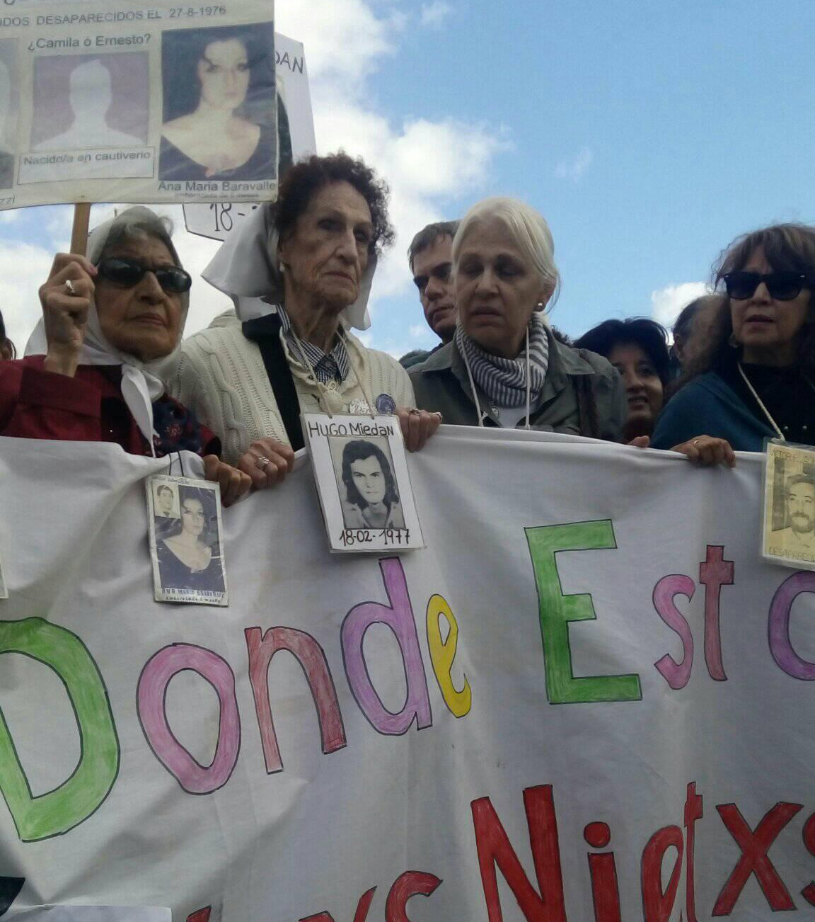

Why push for people-centered SSC at BAPA+40?
Jennifer del Rosario-Malonzo, IBON International

As one of the founders of the Southern CSO Alliance on SSC, IBON International supports this side event being organized to look back to the historical roots of South-South Cooperation and for civil society to keep it from running astray. Civil society has placed high hopes on it being founded on solidarity against colonialism and neocolonialism as well as on the principles of horizontality, equality, respect for national sovereignty, self-reliance, mutual benefit, among others”. She noted, however, that despite its highly progressive roots and principles, SSC has remained a government-to-government affair or pursued as commercial undertakings, with increasing evidence of going astray. Geopolitical interests by powerful countries prevail alongside poverty, lack of accountability, limited space for meaningful peoples’ participation, and various issues of human rights. The side event, thus, aims to serve as a reminder, especially for CSOs to push governments for a people-centered SSC.
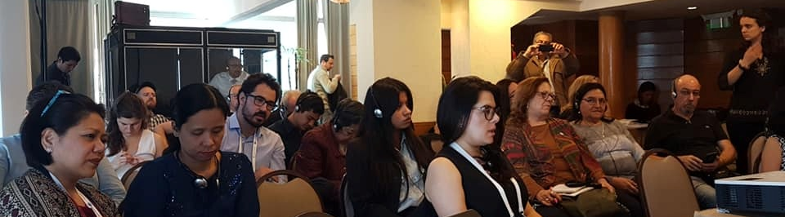

What is a people-centered approach?
Beverly Longid, CPDE

A people-centered approach is rooted in the people’s and nations’ right to development. It is a conceptual framework for the process of human development that is normatively based on international human rights standards and operationally directed to promoting and protecting human rights. It seeks to analyze inequalities which lie at the heart of development problems and redress discriminatory practices and unjust distributions of power that impede development progress. In this approach, human rights determine the relationship between individuals and groups with valid claims (rights-holders) and State and non-state actors with correlative obligations (duty-bearers). It identifies who the rights-holders and duty-bearers are and works towards strengthening their capacities to make their claims (rights-holders) and to meet their obligations (duty-bearers). In development cooperation, this means that all programs, policies and technical assistance should further the realization of human rights as laid down in the Universal Declaration of Human Rights and other international human rights instruments. This includes all development cooperation directed towards the achievement of the Sustainable Development Goals and the Agenda 2030.

People-centered approach applied to South-South Cooperation
Vitalice Meja, ROA-Africa

Human rights based approaches to SSC are based on three aspects: political, economic and technical. South-South Development Cooperation or SSDC is one aspect and should lead to empowerment and human development. HRBA framework for monitoring SSDC implies that human rights serve as a guidance and yardstick for development cooperation and policy across all sectors and levels of intervention in the South. HRBA analyzes inequalities and seeks redress. At the moment, however, it’s not human rights but rather countries’ historical ties and own interests that feature in SSC, and measuring SSC’s development impact is still highly contested. Practically speaking, a human rights-based framework for SSDC means that government institutions in the South should no longer see themselves as mere service providers but ‘duty-bearers,’ who are under an obligation to deliver on people’s empowerment.

It means all programs and policies should be towards the realization, promotion, and protection of human rights. It should contribute to capacity development of both the duty bearers and rights holders: (a) the capacity of duty bearers to meet their obligations to their citizens, and to provide space for people to claim their rights; supporting social, economic, political and cultural rights of people towards empowerment; enabling them to get decent jobs, wages, health, education, etc.; and (b) for rights-holders to claim those rights. It seeks to measure among other ownership, sustainability, and accountability, and facilitates country and stakeholder learning. In assessing ownership, broadly speaking, it looks at the extent to which SSDC aligns with democratically determined country priorities and priorities. In terms of accountability, it checks, among others, the extent through which accountability process is inclusive and participatory, and includes monitoring, evaluation, accountability mechanisms and remedies. In monitoring sustainability, it looks into the extent to which projects and initiatives have developed technical capacity to translate human rights into effective peoples’ empowerment policies with appropriate budget allocations, as well as support structures, policies and legal frameworks.
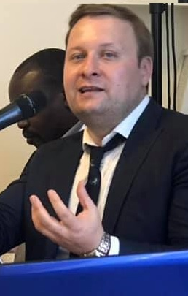
The need for a CSO HRBA framework: An IGO Perspective
Artemy Izmetsiev, UNDP Seoul Policy Center

Its emergence, South-South Cooperation has been remarkably state-centric. Most of the Bandung principles refer to the states (except “Promotion of mutual interests and cooperation” that can be interpreted in different ways). In 1978, BAPA took a similar approach mostly focusing on state-to-state cooperation, even though it acknowledged the multidimensional nature of TCDC (bilateral or multilateral in scope, and sub-regional, regional or interregional in character). It should be organized by and between Governments which can promote, for this purpose, the participation of public organizations and, within the framework of the policies laid down by Governments, that of private organizations and individuals). This state-centric nature of SSC is a limiting factor to the role of CSOs in implementation and policy dialogue around it. In North-South cooperation, CSOs played a very important role to raise awareness of malpractices in ODA projects, but also made a significant contribution to a better system for development effectiveness of ODA (also enabled by a relatively good set of ODA transparency standards).

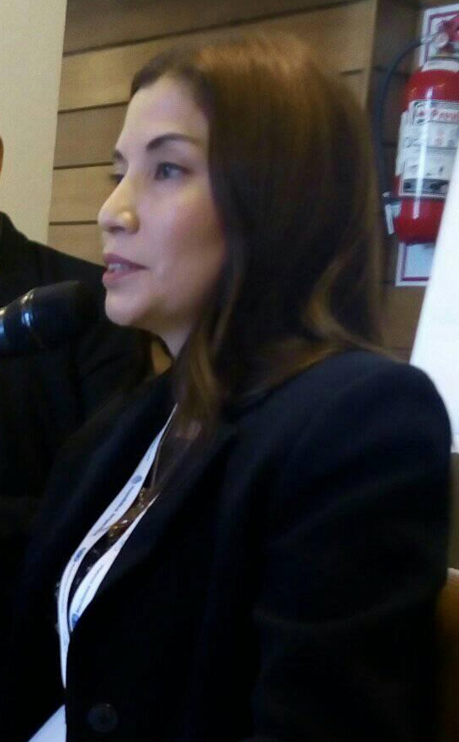
In the absence of the clear SSC definition and development effectiveness frameworks (including transparency), it is difficult for the civil society organizations to make informed statements on SSC activities. There are efforts to develop such frameworks, such as those developed by national governments and academics such as NeST. While they are, at times, used by CSOs, it was useful to develop a framework addressing the specific needs of the CSOs, however challenging it may be. There are some methodological challenges in the development of such a framework that still need to be addressed and resolved. For example, whereas the CSOs naturally focus on human-rights approach, this approach with “duty bearers” and “right holders” can be difficult to apply to the voluntary SSC. The human rights narrative for SSC needs to be developed.

Involving CSOs in SSC: The Peruvian Practice
Nancy Silva, Agencia Peruana de Cooperacion Internacional (APCI), Peru

Quantification and measuring international technical cooperation impacts are still a challenge given its complexity and multi-stakeholder approach. Thus, it is necessary to, among others, encourage participatory work to achieve effective partnerships, which involves multiple development actors, specifically local actors that allows ownership of the initiatives’ results. Peru, through the Declaration of International Technical Cooperation Policy of the Ministry of Foreign Affairs, established a strategic guideline to work with civil society. APCI, particularly, highlights the role of CSOs as a strategic ally for development. NGOs have been incorporated as members within the National Decentralized System of ITC, which enables them to participate in the Annual Report wherein they record the execution of ITC resources. Furthermore, APCI has been promoting the Multi-stakeholder Partnership for Sustainable Development Cooperation. To facilitate the participation of CSOs in the field of international cooperation, through SSC and other modalities, we can work together to:

- Promote political and strategic frameworks that facilitate multi-stakeholder work
- Promote and strengthen efficient coordination mechanisms between the public sector and CSOs, mainly at regional and local levels.
- Contribute in the identification of potential partners for multi-stakeholder partnerships.
- Strengthen public entities’ capacities in working with CSOs to implement SSC and TC initiatives.
- Promote innovative financing mechanisms to make more dynamic SSC and TC and to promote the mobilization of public and private resources, to establish innovative mechanisms available and accessible to civil society.
- Include CSOs in various innovative mechanisms and schemes of ITC such as SSC, TC and multi-stakeholder partnerships, which implies a new dynamic of work and new challenges.
- Improve national information systems to measure the contribution of development stakeholders, particularly CSOs.
- Services provided by the APCI to CSOs (NGOs) should be expanded for proper management of ITC.

SSC in Latin America and Carribbean
Camilo Molina of CPDE-LAC Regional Observatory

LAC countries in the past decade showed increased participation in SSC and triangular cooperation. CSOs, through the CPDE LAC Regional Observatory, carried out an exercise on the state and perception of the dynamics of SSC. Bilateral SSC builds capacity in the area of economic development, mostly to strengthen productive sectors (notably agriculture), and to some extent supporting infrastructure and services, social welfare, government and civil society strengthening, environment, and culture. In triangular cooperation, Germany stood out among Northern providers, followed by Spain and Japan, the US, and multilateral organizations (UN), several development banks and some sub-regional institutions; with most active Southern LAC recipients being Paraguay, El Salvador, Guatemala, and Honduras. Triangular cooperation arrangements are likewise for economic purposes – mainly supporting the productive sectors; as well as for social services, environment and institutional strengthening. As to regional cooperation, Mexico was the most active among the countries. Also key players were multilateral organizations, particularly Ibero-American organizations. More than half of regional cooperation projects were for addressing social and economic problems. From all the data monitored, there is lack of information on the participation of CSOs in SSC programs. Undoubtedly, CSOs need an enabling environment to undertake their activities and participate in SSC. There is also a need for a focus on human rights to make SSC truly effective.
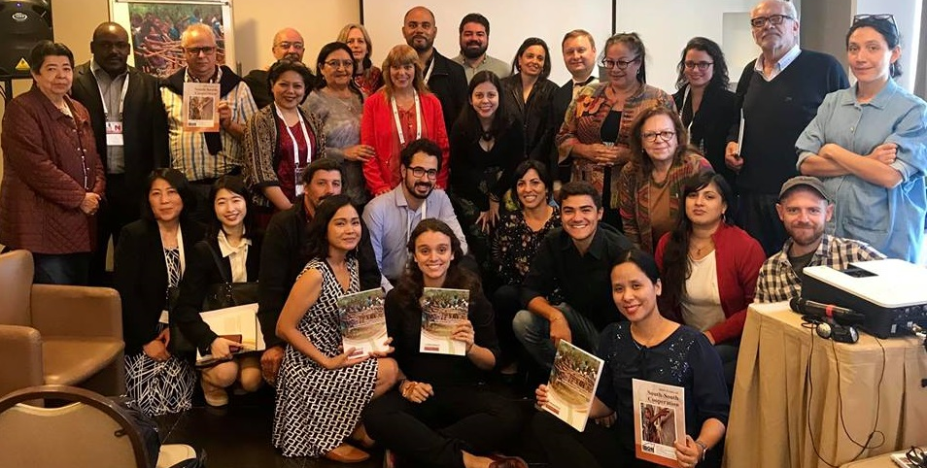
The side event featured/launched ROA-CPDE’s Policy Research on Operationalizing People-Oriented South-South Development Cooperation 2018

SSC should be for the people, by the people.
Heke Warren of PIANGO; Denis Nkala UNOSSC Asia Pacific

“If it’s not for the people, what is SSC for? Why are we even doing it?” Heke Warren stressed that the people should be put at the center of this cooperation, and that we should actively engage the youth. Similarly, UNOSSC Asia Pacific’s Denis Nkala said that “if SDGs is the GPS, the people are the drivers.” SSC should be demand-driven, thus, the people must participate in planning and evaluation of which type of projects must be done. The people and their communities should be the one to determine the specific type of cooperation that can benefit them. A lot of partnerships between states have been done under SSC but most of them are market-driven which facilitated the further corporate capture of development. Development under SSC has been for the benefit of the powerful states, IFIs and business sector instead of being for the benefit of the people.

Assessment and ways forward
ROA, CPDE, Southern CSO Alliance on South-South Cooperation

The side event could only cover so much and everyone expressed interest in continued engagement in SSC. At the (expanded) Southern CSO Alliance on SSC assessment of their whole BAPA engagement, members and other CSOs in general were frustrated by the UNOSSC/host country's lack of system that limited CSOs' operations and ability to engage and influence the outcome, and said focus should not be just on UN conference engagement. Nonetheless, for a young and loose coalition, the efforts were a good start. Proposed ways forward were to strengthen the Alliance (how it should operate) and engage in focused partnerships (i.e. with Peru, Indonesia, UNDP, UNOSSC) in the aspects of policy and projects. In terms of project: to do real people-to-people cooperation/SSC in the form of an exchange program (e.g. youth exchange). In terms of policy, the proposals were:

- focused partnership with Peru and Indonesian governments as pilots on the institutionalization of CSO participation/ coming up with a policy framework
- research/mapping of models of effective partnerships and engagement and a repository on the ROA website of how effective CSOs can be in engaging governments (e.g. sectoral)
- FfD (May), DCF (August) engagement
- more awareness raising on people-centered SSC
- follow up work at country level

Programme

Time | Topic | Speaker(s)
9:00-9:10 (10min) | Welcome Remarks: The Local Context of BAPA’s adoption and what it means for Argentine CSOs today | Marita Gonzales, Confederacion General del Trabajo Internacional – Argentina
9:10-9:20 (10min) | Side event background, rationale, objectives, output/outcome | Jennifer Malonzo, IBON International
9:20-9:30 (10min) | What is a people-centred approach? | Beverly Longid, CSO Partnership for Development Effectiveness (CPDE)
9:30-9:40 (10min) | People-centred framework for SSDC: What is it and how will it strengthen the institutional framework for SSC? | Vitalice Meja, RoA-Africa
9:40-10:40  (60 min) | How can state and non-state actors cooperate in applying people-centered approaches in SSDC? What are some efforts, challenges and opportunities?  - Provider, Recipient/ Dual-role country Perspective  - Triangular cooperation partners  - CSOs | Artemy Izmetsiev, UNDP Seoul Policy Center  Nancy Silva Sebastian, APCI Peru  Denis Nkala, UNOSSC Asia Pacific  Camilo Molina, LAC Regional Observatorio  Heke Warren, PIANGO
10:40-11:20 (30min, open to extension if needed) | Q&A / Interactive Discussion | Lyn Angelica Pano,  Southern CSO Alliance on South-South Cooperation; The Reality of Aid Network
11:20-11:30 (10min) | Synthesis and Concluding Remarks: Ways Forward
Emcee: Lyn Angelica Pano

Participants

The side event was well-attended with around 30 participants from various Latin American countries (Argentina, Ecuador, Mexico, Brazil, Peru, El Salvador), as well as Asia, Pacific, and Africa. It was multi-stakeholder, with two inter-governmental organizations (UNDP and UNOSSC Asia Pacific) and one government representative (APCI, Peru). It was a very light and lively discussion that shed light on the people-centered approach to SSC that gathered positive feedback from participants. Because of the limited time for discussion (and interpretation) for what participants found to be a very interesting subject matter, they were keen on a more thorough discussion as a follow through.

NAME | ORGANIZATION | EMAIL
- Jennifer Malonzo | IBON International | jmalonzo@iboninternational.org
- Gustavo F.C. Garcia | Uniao Gerac dos Trabalhadores- Brasil | Garcia_ugt@hotmail.com
- Thiago C. Maeda | Central Unica dos Trabalhadores- Brasil | thiago@cut.org.br
- Laura Becerra Poros | DECA, Equipo Pueblo- Mexico | laurabecerraep@gmail.com
- Facundo Reynoso | Etis, Red de Encuentro | freynoso@agro.uba.ar
- Marta Benavides | Siglo XXIII- El Salvador | tlalibertad@gmail.com
- Claudio R. Bevilacqua | ILPS Argentina | claudiobevilacqua@gmail.com
- Gabriela Tolosa | ILPS Argentina | gabtolosa@gmail.com
- Nancy Silva | APCI Peru | nsilva@apci.gob.pe
- Bruno Baldo | Escuela Popular de Musica | baldobruno@gmail.com
- Pascual Duarte | Cuba MTR/ ILPS | turkisman88@gmail.com
- Kuperman Oscar | ILPS- Argentina | oscarkuperman@gmail.com
- Yuri Tamiguchi | IPPF | ytaniguchi@ippf.org
- Claudio Darice | ILPS | roetaslocos2003@yahoo.com
- Juliana Costa | ASUL Brazil | j.costa@articulacaosul.org
- Carina Von Dertel | APL-CGTA-PAMPA2030 | cvonoertel@gmail.com
- Myriam Peres | UTSA-CGT-PAMPA2030 | myriam_peres@hotmail.com
- Rafael Guirano | SADOP-CGTRA-PAMPA2030 | rafaelguirado@gmail.com
- Micaela Bracco | INAS-CISL ARG- PAMPA2030 | m.brocco@pasi.it
- Luara Lopes | ASUL Brazil | l.lopes@articulacaosul.org
- Heke Warren | Pacific Islands Association of NGOs | hekewarren@bigpond.com
- Denis Nkala | UNOSSC Asia Pacific | denis.nkala@unossc.org
- Orndaporn Peumgern | UNOSSC Asia Pacific | ornadaporn.peumgern@unossc.org
- Marcela Browne | Fundacion SES | marcelabrowne@fundses.org.ar
- Ju Yeon Kim | UNDP Argentina | ju.yeon.kim@undp.org
- Joyce Loares | FORUS | joyce@forus-international.org
- Malena Fama | APDENA | malena.aoed@apdena.org
- Vitalice Meja | Reality of Aid - Africa | meja@roaafrica.org
- Beverly Longid | CPDE, IPMSDL | beverly.longid@gmail.com
- Marita Gonzales | ITUC-Argentina, CPDE | maritagonzalez@cgtrainternacional.com.ar
- Artemy Izmetsiev | UNDP Seoul Policy Center | artemy.izmetsiev@undp.org
- Josefina Villegas | FLACJ, CPDE | josefina.villegas@flacj.org
- Camilo Molina | LAC Regional Observatorio, Ecuador | camimolinv@gmail.com
- Lyn Angelica Pano | The Reality of Aid Network | lpano@realityofaid.org

